Python:

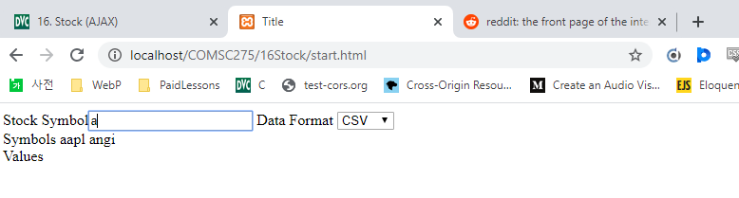

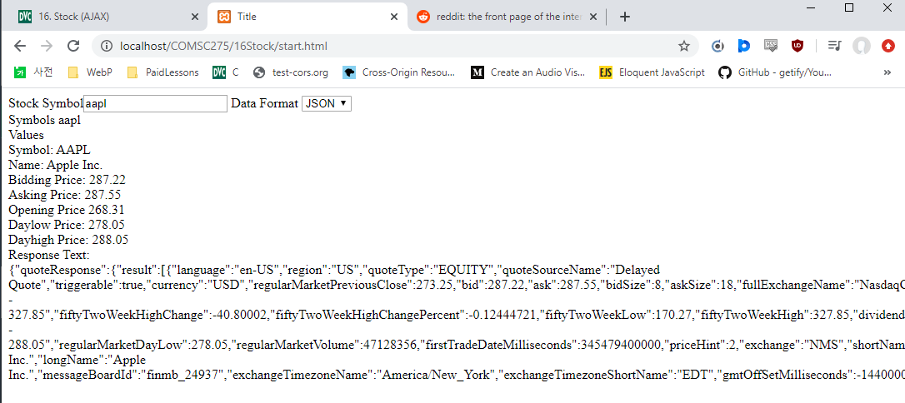

Start.html

<!DOCTYPE html>  
  
<html lang="en">  
  
<head>  
 <meta charset="UTF-8">  
 <title>Title</title>  
<script>  
// create XMLHttpRequest object as a global variable  
  
var myReq = new XMLHttpRequest();  
// The function below is invoked on pressing any key and releasing it  
// in text field.  
  
// It communicates with object XMLHttpRequest to perform ajax  
// It sets up in the object the callback method to be called and the  
// url of the script to be invoked and query string to be passed to it.  
// The query string contains partially typed symbol and a random number.  
// The random number is used to make the url unique and avoid  
// getting the cached response.  
  
function searchStock(value,event) {  
  
 //alert("searchStock");  
  
 var thePage;  
 var theURL;  
 var keyCode = event.keyCode;  
  
 if(keyCode=="13"){  
 thePage = "searchStock.py";  
 theURL = thePage +"?symbol=" + value;  
  
 var format = document.getElementById("idFormat").value;  
  
 theURL = theURL + "&format=" + format;  
  
 myReq.onreadystatechange = theHTTPResponse2;  
 }  
 else {  
 thePage = "searchSymbol.py";  
 theURL = thePage +"?symbol=" + value;  
 myReq.onreadystatechange = theHTTPResponse;  
  
 }  
  
 myRand = parseInt(Math.random()*999999999999999);  
  
 theURL = theURL +"&rand="+myRand;  
  
 myReq.open("GET", theURL, true);  
 //alert ("searchStock2");  
 myReq.send(null);  
 //alert ("searchStock3");  
}  
  
// The following callback function is called by object XMLHttpRequest  
// whenever its ready state changes. When ready state is 4  
// (i.e. request is completed) and HTTP status is 200 (i.e. OK),  
// it copies the script response in the span.  
  
function theHTTPResponse() {  
 //alert("theHTTPResponse");  
 if (myReq.readyState == 4 && myReq.status == 200) {  
 //alert("theHTTPResponse: "+ myReq.responseText);  
 document.getElementById("idStockGuess").innerHTML =  
 myReq.responseText;  
  
 }  
}  
  
function theHTTPResponse2() {  
  
 //alert("theHTTPResponse2 "+myReq.readyState);  
 //alert("theHTTPResponse2 "+myReq.status);  
  
 if (myReq.readyState == 4 && myReq.status == 200) {  
  
 //alert("Response Text: " + myReq.responseText.length);  
  
 var format = document.getElementById("idFormat").value;  
  
 var out="";  
  
 switch (format){  
  
 case "csv":  
  
 if (myReq.responseText.length<=1){  
  
 out="csv format not available";  
  
 }  
  
 break;  
  
 case "xml":  
  
 if (myReq.responseText.length<=1){  
  
 out="xml format not available";  
  
 }  
  
 break;  
  
 case "json":  
  
 if (myReq.responseText.length<=1){  
  
 out="json format not available";  
  
 }  
  
 else {  
 var JSONObj = JSON.parse(myReq.responseText);  
 var symbol = JSONObj.quoteResponse.result[0].symbol;  
 var name = JSONObj.quoteResponse.result[0].longName;  
 var bid = JSONObj.quoteResponse.result[0].bid;  
 var ask = JSONObj.quoteResponse.result[0].ask;  
 var open = JSONObj.quoteResponse.result[0].regularMarketOpen;  
 var dayLow = JSONObj.quoteResponse.result[0].regularMarketDayLow;  
 var dayHigh = JSONObj.quoteResponse.result[0].regularMarketDayHigh;  
  
 out += "Symbol: " + symbol + "<br>";  
 out += "Name: " + name + "<br>";  
 out += "Bidding Price: " + bid + "<br>";  
 out += "Asking Price: " + ask + "<br>";  
 out += "Opening Price " + open + "<br>";  
 out += "Daylow Price: " + dayLow + "<br>";  
 out += "Dayhigh Price: " + dayHigh + "<br>";  
 out += "Response Text:<br>"+myReq.responseText + "<br >";  
  
 }  
 break;  
 default:  
 out="format not available";  
  
 break;  
 }  
  
 document.getElementById("idStockValue").innerHTML=out;  
 }  
}  
  
//The following function is invoked on clicking the span.  
//It copies the content of the span (i.e. script response) to text field.  
function setStock(stock){  
 document.getElementById("idStock").value = stock;  
}  
  
</script>  
  
</head>  
  
<body>  
Stock Symbol<input type="text" id="idStock"  
  
 onkeyup="searchStock(this.value,event)" />  
Data Format  
<select name="format" id="idFormat">  
 <option value="csv" selected>CSV</option>  
 <option value="json">JSON</option>  
 <option value="xml">XML</option>  
</select><br />  
  
Symbols <span id="idStockGuess"  
 onclick="setStock(this.innerHTML)">  
 </span><br />  
  
Values<br />  
<span id="idStockValue" ></span><br />  
  
</body>  
  
</html>

searchStock.py

#!/Python27/python  
  
import cgi  
  
import requests  
  
f=cgi.FieldStorage()  
symbol=f.getvalue('symbol')  
format=f.getvalue('format')  
  
print("Content-type: text/txt\n\n")  
  
#returns json  
if format == 'json':  
  
 r=requests.get(  
 "https://query1.finance.yahoo.com/v7/finance/quote?symbols="+symbol)  
  
 #status_code=r.status_code  
 #s=(str(status_code))  
 s=r.text  
  
else:  
 s = ""  
  
print(s)

searchSymbol.py

#!/Python27/python  
  
import cgi  
  
print("Content_type: text/xml\n\n")  
  
symList = ["aapl", "msft", "goog", "googl", "ibm", "angi"]  
  
f = cgi.FieldStorage()  
  
sym = f.getvalue("symbol")  
  
matches = ""  
  
for symbol in symList:  
  
 if len(sym) > 0 and len(symbol) >= len(sym):  
 sym = sym.lower()  
 symbol = symbol.lower()  
  
 if sym == symbol[0:len(sym)]:  
  
 if matches == "":  
 matches = symbol  
  
 else:  
 matches = matches + " " + symbol  
  
if matches == "":  
 matches = "No Match"  
  
print(matches)

PHP:

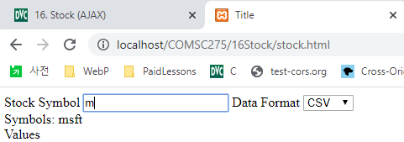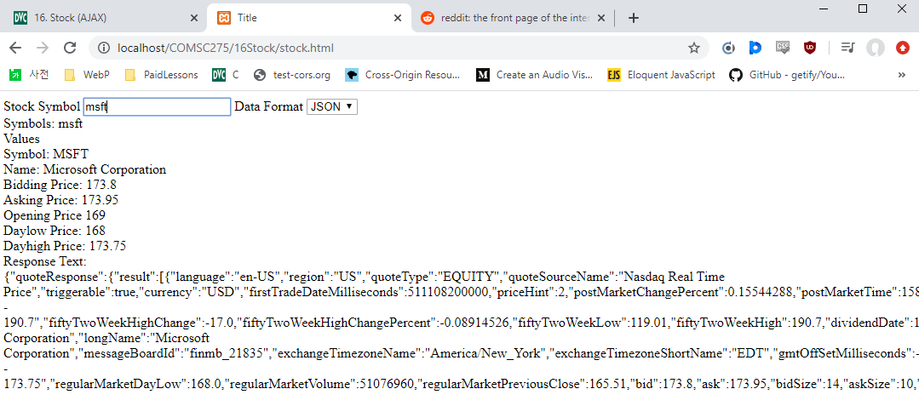

Stock.html

<!DOCTYPE html>

<html lang=*"en"*>

<head>

<meta charset=*"UTF-8"*>

<title>Title</title>

<script>

// create XMLHttpRequest object as a global variable

**var** myReq = **new** XMLHttpRequest();

// The function below is invoked on pressing any key and releasing it

// in text field.

// It communicates with object XMLHttpRequest to perform ajax

// It sets up in the object the callback method to be called and the

// url of the script to be invoked and query string to be passed to it.

// The query string contains partially typed symbol and a random number.

// The random number is used to make the url unique and avoid

// getting the cached response.

**function** searchStock(value,event) {

//alert("searchStock");

**var** thePage;

**var** theURL;

**var** keyCode = event.keyCode;

**if**(keyCode=="13"){

thePage = "searchStock.py";

theURL = thePage +"?symbol=" + value;

**var** format = document.getElementById("idFormat").value;

theURL = theURL + "&format=" + format;

myReq.onreadystatechange = theHTTPResponse2;

}

**else** {

thePage = "searchSymbol.py";

theURL = thePage +"?symbol=" + value;

myReq.onreadystatechange = theHTTPResponse;

}

myRand = parseInt(Math.random()*999999999999999);

theURL = theURL +"&rand="+myRand;

myReq.open("GET", theURL, **true**);

//alert ("searchStock2");

myReq.send(**null**);

//alert ("searchStock3");

}

// The following callback function is called by object XMLHttpRequest

// whenever its ready state changes. When ready state is 4

// (i.e. request is completed) and HTTP status is 200 (i.e. OK),

// it copies the script response in the span.

**function** theHTTPResponse() {

//alert("theHTTPResponse");

**if** (myReq.readyState == 4 && myReq.status == 200) {

//alert("theHTTPResponse: "+ myReq.responseText);

document.getElementById("idStockGuess").innerHTML =

myReq.responseText;

}

}

**function** theHTTPResponse2() {

//alert("theHTTPResponse2 "+myReq.readyState);

//alert("theHTTPResponse2 "+myReq.status);

**if** (myReq.readyState == 4 && myReq.status == 200) {

//alert("Response Text: " + myReq.responseText.length);

//alert(myReq.responseText);

**var** format = document.getElementById("idFormat").value;

**var** out="";

**switch** (format){

**case** "csv":

**if** (myReq.responseText.length<=1){

out="csv format not available";

}

**break**;

**case** "xml":

**if** (myReq.responseText.length<=1){

out="xml format not available";

}

**break**;

**case** "json":

**if** (myReq.responseText.length<=1){

out="json format not available";

}

**else** {

**var** JSONObj = JSON.parse(myReq.responseText);

**var** symbol = JSONObj.quoteResponse.result[0].symbol;

**var** name = JSONObj.quoteResponse.result[0].longName;

**var** bid = JSONObj.quoteResponse.result[0].bid;

**var** ask = JSONObj.quoteResponse.result[0].ask;

**var** open = JSONObj.quoteResponse.result[0].regularMarketOpen;

**var** dayLow = JSONObj.quoteResponse.result[0].regularMarketDayLow;

**var** dayHigh = JSONObj.quoteResponse.result[0].regularMarketDayHigh;

out += "Symbol: " + symbol + "<br>";

out += "Name: " + name + "<br>";

out += "Bidding Price: " + bid + "<br>";

out += "Asking Price: " + ask + "<br>";

out += "Opening Price " + open + "<br>";

out += "Daylow Price: " + dayLow + "<br>";

out += "Dayhigh Price: " + dayHigh + "<br>";

out += "Response Text:<br>"+myReq.responseText + "<br >";

}

**break**;

**default**:

out="format not available";

**break**;

}

document.getElementById("idStockValue").innerHTML=out;

}

}

//The following function is invoked on clicking the span.

//It copies the content of the span (i.e. script response) to text field.

**function** setStock(stock){

document.getElementById("idStock").value = stock;

}

</script>

</head>

<body>

Stock Symbol <input type=*"text"* id=*"idStock"*

onkeyup="searchStock(this.value,event)" />

Data Format

<select name=*"format"* id=*"idFormat"*>

<option value=*"csv"* selected>CSV</option>

<option value=*"json"*>JSON</option>

<option value=*"xml"*>XML</option>

</select><br />

Symbols: <span id=*"idStockGuess"* onclick="setStock(this.innerHTML)">

</span><br />Values<br />

<span id=*"idStockValue"* ></span><br />

</body>

</html>

searchStock.php

<?php

$symbol=**$_GET**['symbol'];

$format=**$_GET**['format'];

//reurns output in JSON format

**if** ($format=='json') {

$s = *file_get_contents*(

"https://query1.finance.yahoo.com/v7/finance/quote?symbols="

. $symbol

);

}

**else**{

$s = "";

}

**print** $s;

?>

searchSymbol.php

<?php

// Fill the array with stock symbols

$list[]="aapl";

$list[]="msft";

$list[]="goog";

$list[]="ibm";

$list[]="wfm";

$list[]="sfm";

$list[]="tfm";

$list[]="bac";

$list[]="wfc";

$list[]="hpq";

$list[]="orcl";

$list[]="intc";

$list[]="angi";

$list[]="bbry";

$list[]="fb";

$list[]="hd";

$list[]="m";

//get the partial symbol if provided

**if** (**isset** (**$_REQUEST**["symbol"])){

$symbol=**$_REQUEST**["symbol"];

}

**else** {

$response="no match";

**exit**;

}

$matches="";

//check for all matches in the list array with user supplied symbol

**if** (*strlen*($symbol) > 0){

**for**($i=0; $i<*count*($list); $i++){

**if** (*strtolower*($symbol)

== *strtolower*(*substr*($list[$i],0,*strlen*($symbol)))){

**if** ($matches==""){

$matches=$list[$i];

}

**else**{

$matches=$matches." , ".$list[$i];

}

}

}

}

// Set output to "no match" if no matches were found

// Otherwise set output to the matched list.

**if** ($matches == ""){

$response="no match";

}

**else**{

$response=$matches;

}

//output the response

**print** $response;

?>